Serviced Residences | 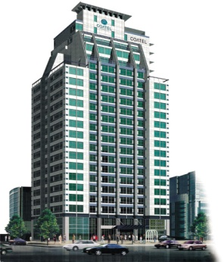

In advance, I sincerely hope for your esteemed company’s success & development.

The COATEL is the newest style accommodation would like to serve your esteemed company’s honored customers with low-price and special service as same as special grade hotels.
What is COATEL?
The serviced accommodation of the largest scale in domestic gathered advantages from Condominium, Office, Apartment and Hotel

* ROOMRATE
Less than 30. (included 10% V.A.T)
RoomType | Rack Rate | Special Rate
Deluxe Double | \200,000 | \132,000
Deluxe Twin | \220,000 | \132,000
Exeutive Suite | \300,000 | \175,000
Coatel Suite | \400,000 | \220,000

* Breakfast is 13,000 won per 1 person (excluded 10% V.A.T)-
* Gym and sauna is 12,000 won per 1 person (included 10% V.A.T)
* Free high speed internet.

* Reservation : Marketing Team Sales Manager Park Seo Young
TEL: 02-6288-3402 FAX: 02-6288-3408
Mobile: 010-7471-6288 E-mail: sales3@coatel.co.kr www.COATEL.co.kr

